Appendix 1
Site Plan

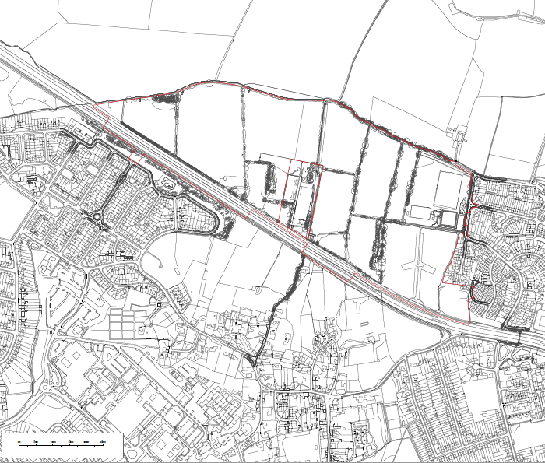

Appendix 2
Public Consultation responses

The following public consultation events were held:

- Meeting with the local youth group – ‘Thrive’
- Meeting with the school council at Bayhards Hill Primary School
- Posters displayed and questionnaires provided at Cheney Secondary School in Headington and at the Barton Leisure Centre
- Displaying the exhibition material on the Barton Park website and questionnaire response facility provided and monitored.

The public consultation events were held on:

- Barton Neighbourhood Centre, Tuesday 1st April, 4-7pm
- Barton Neighbourhood Centre, Saturday 5th April, 10am-2pm
- Northway Community Centre, Tuesday 8th April, 4-7pm

Summary of Consultation Responses | Summary of Changes in response to the consultation
- Provide a range of active play equipment for children to play and in particular climb on. | - Providing an area for natural play in addition to the formal provision of LEAPs.
- Maintaining the clean open spaces that are well managed with particular regard to dog control. | - Inclusion of trim trail and outdoor gym equipment within the green infrastructure.
- A space that can be used for relaxing and opportunities for being near a cleaner Brook. | - To ensure that the majority of the park is accessible by all including the boardwalk and one of the platforms to provide close asccess to the water’s edge.  - Providing opportunities to access Baywater Brook.
- Somewhere that should be easily accessible by all including those with push-chairs and wheelchair users. | - A section of the main path to the east of the linear park has been upgraded to a 2m wide hoggin path to ensure an easily accessible route for all especially during wet weather.Provision of better areas within the linear park for informal kick about space.

Further details about the public consultation responses can be found in the Statement of Community Involvement submitted with the application.

Appendix 3
Oxford Design Review Panel responses: Part 1

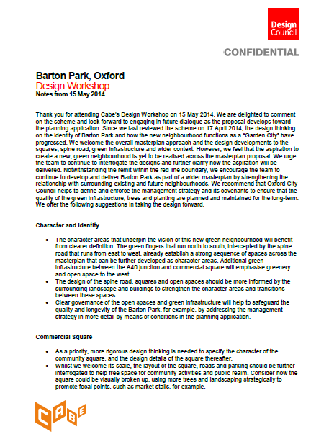

Appendix 3
Oxford Design Review Panel responses: Part 2

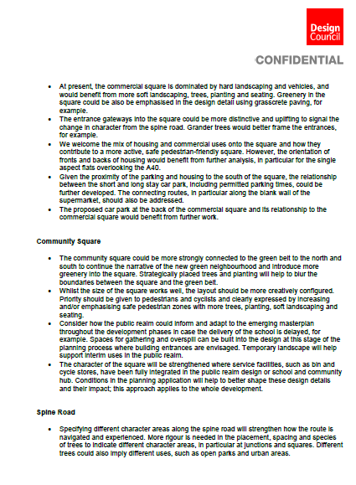

Appendix 3
Oxford Design Review Panel responses: Part 3

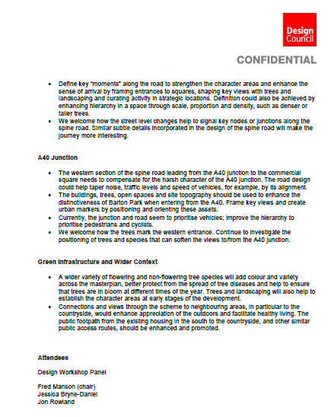

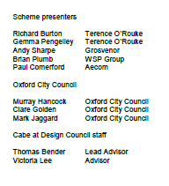
Appendix 4 – Illustrative Masterplan

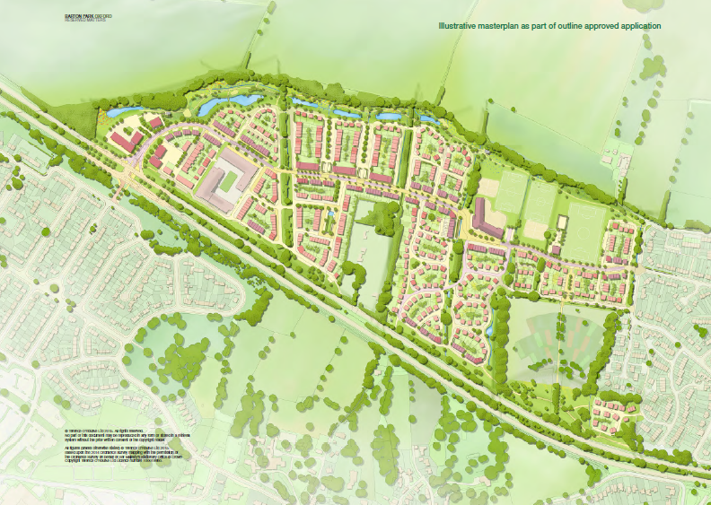

Appendix 5
Parameter Plan 4

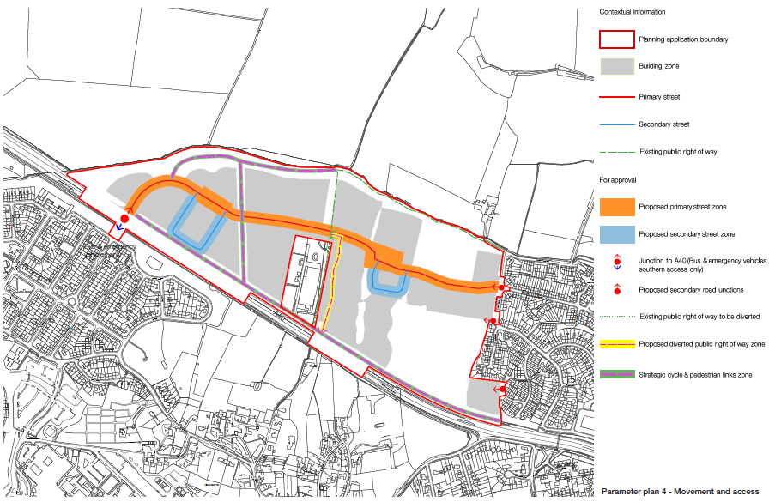

Appendix 6
Parameter Plan 3

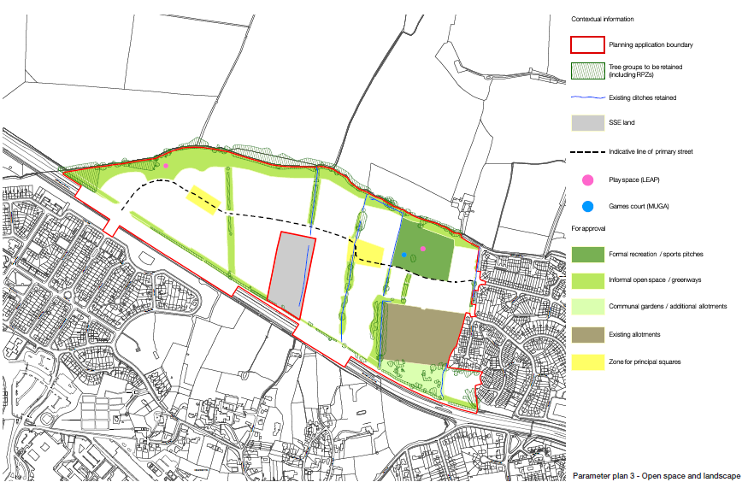

Appendix 7
Proposed A40 Junction

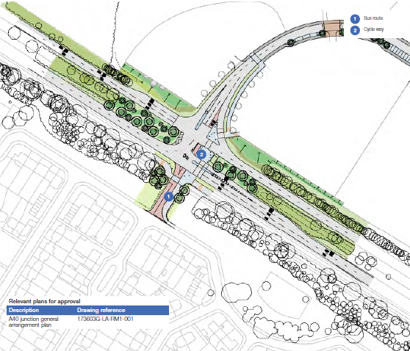

Appendix 8
Earthworks Strategy
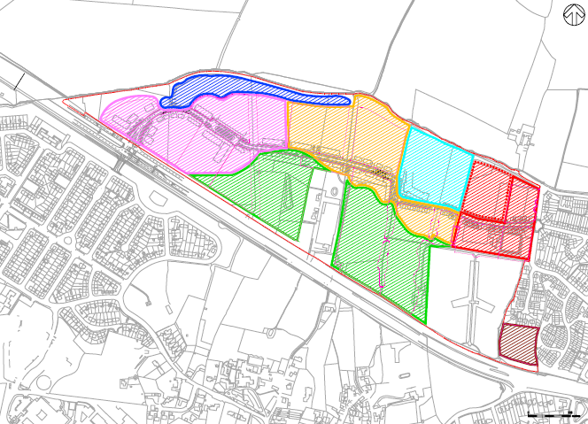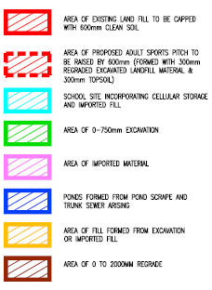

Appendix 9
Temporary construction traffic access from the A40

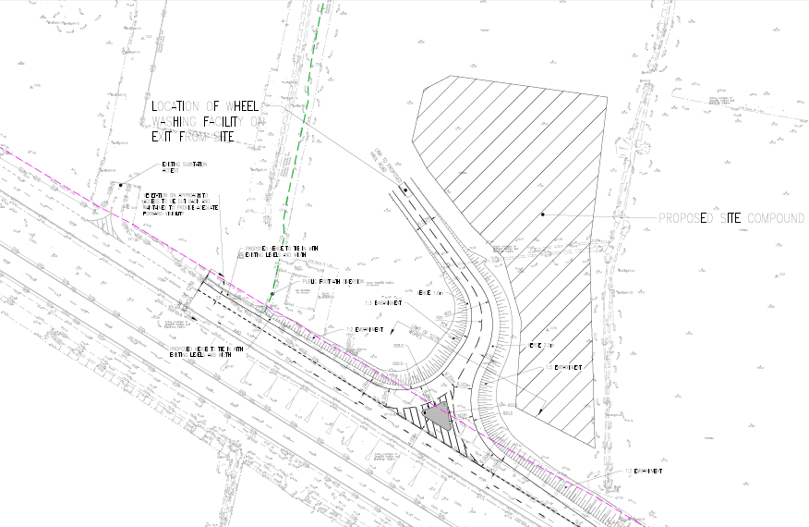

Appendix 10
Haul routes

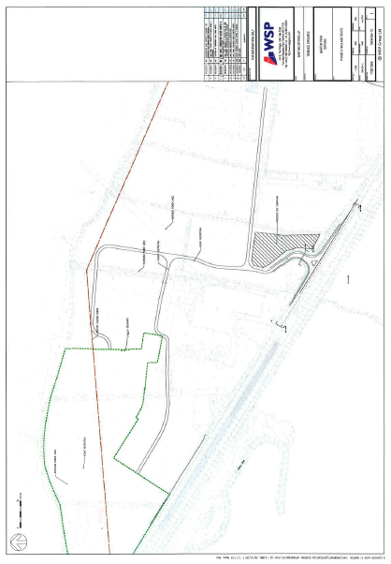

Appendix 11
Extent of 50mph speed limit on A40 and other traffic measures

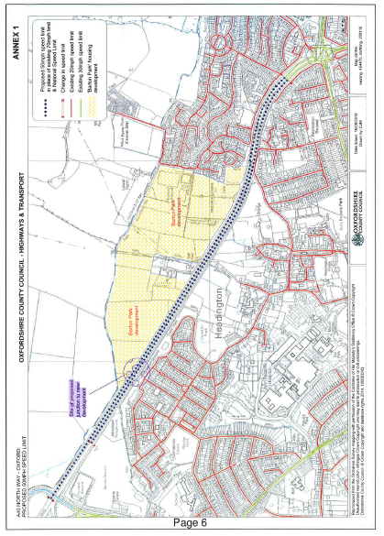

Appendix 11
Extent of 50mph speed limit on A40 and other traffic measures

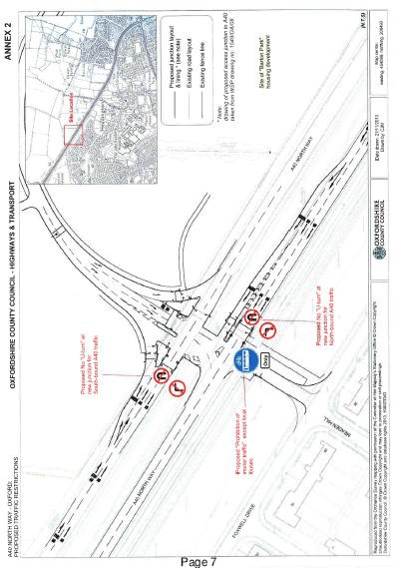

Appendix 12
Primary Street cross-section

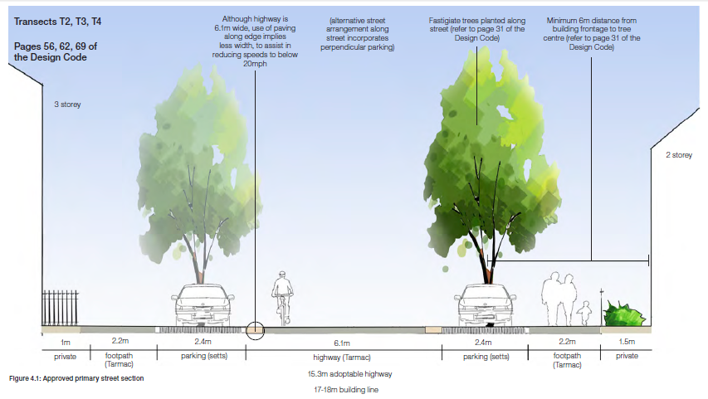

Appendix 13
Commercial Square Layout

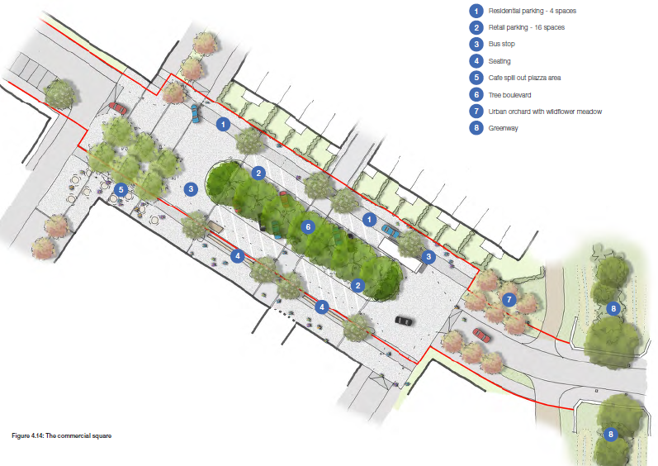

Appendix 14
Community Square Layout

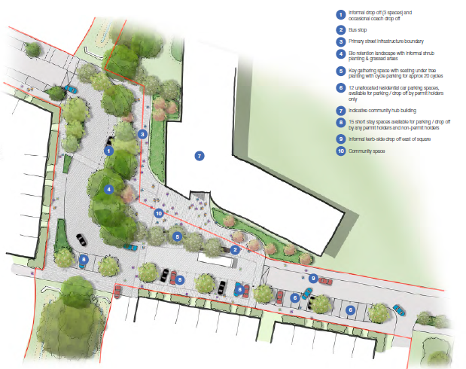

Appendix 15
Linear Park Layout

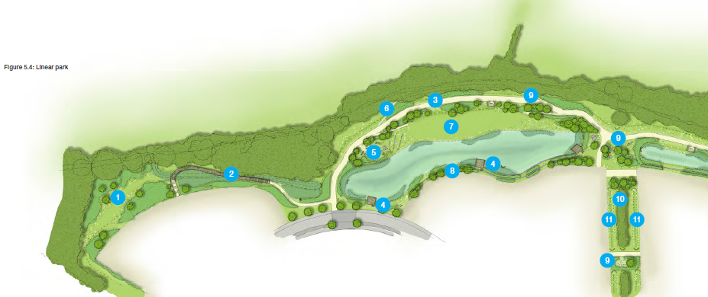

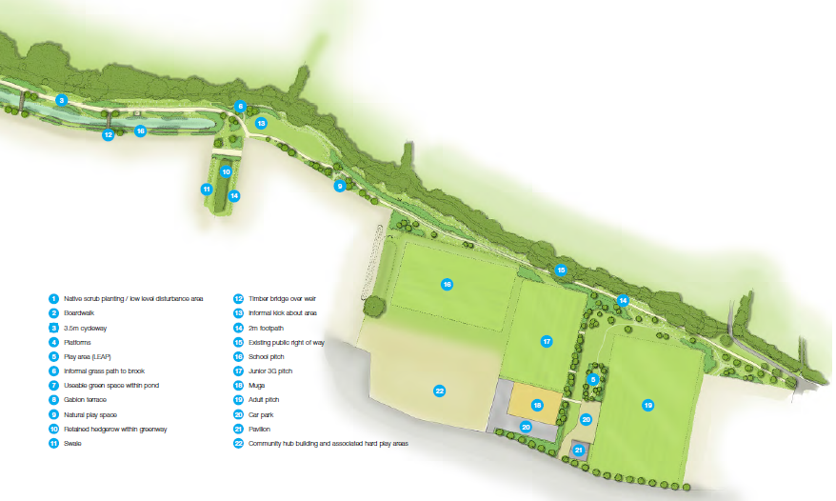

Appendix 16
Linear Park Cross Section

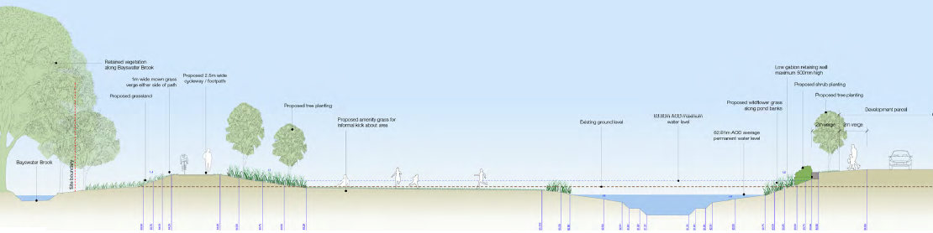

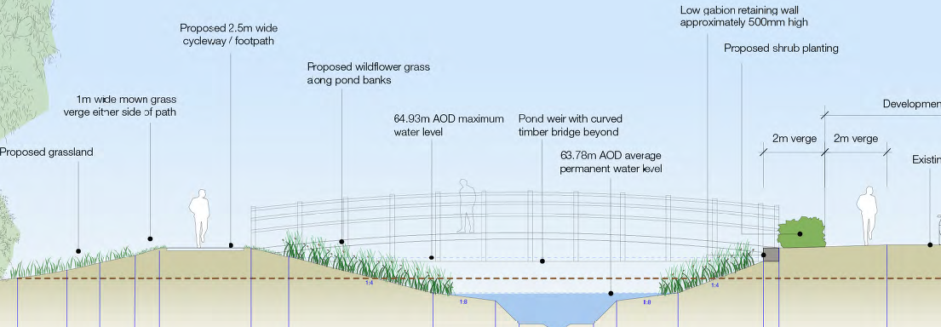

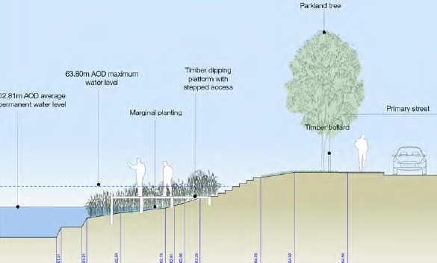

Appendix 17
Safety features for play areas near water

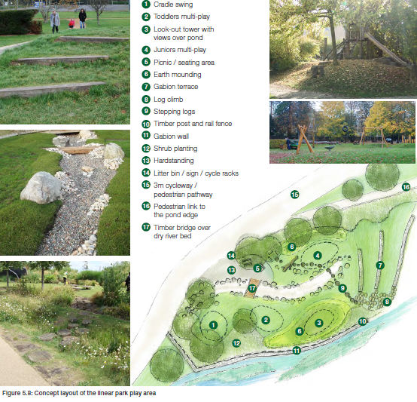

Appendix 18
Linear Park Character Areas

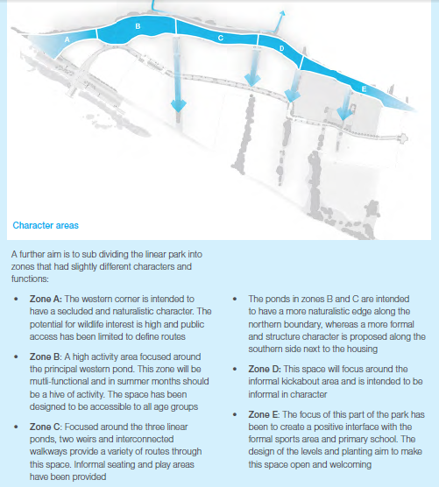

Appendix 19
Greenways

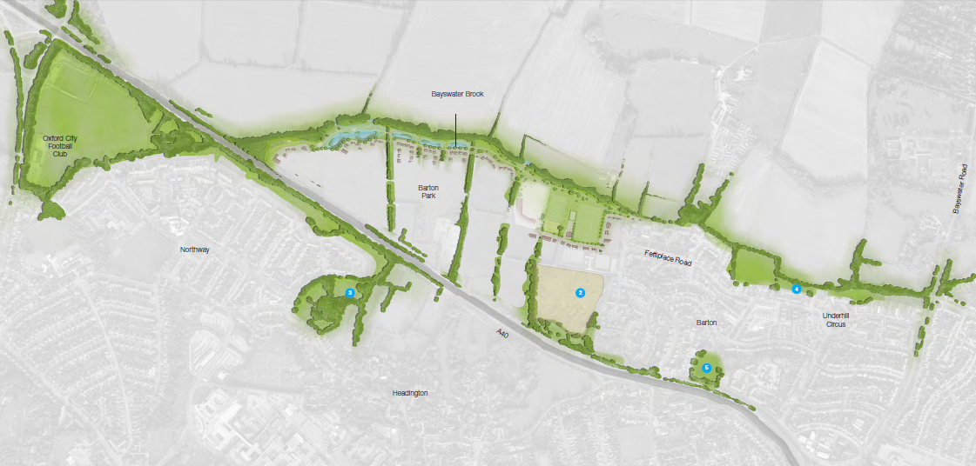

Example of a greenway layout:

